Version Control

Samuel Cooke – s251388

Repository Link
Link: https://github.com/s251388/AIE-2.1.3-Minimum-Element.git
Screenshot:
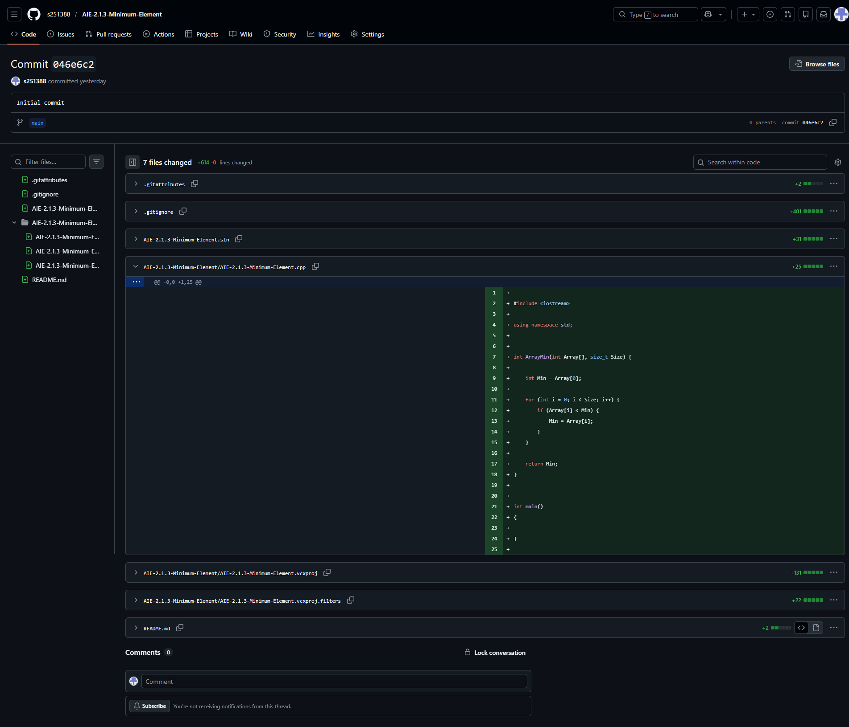
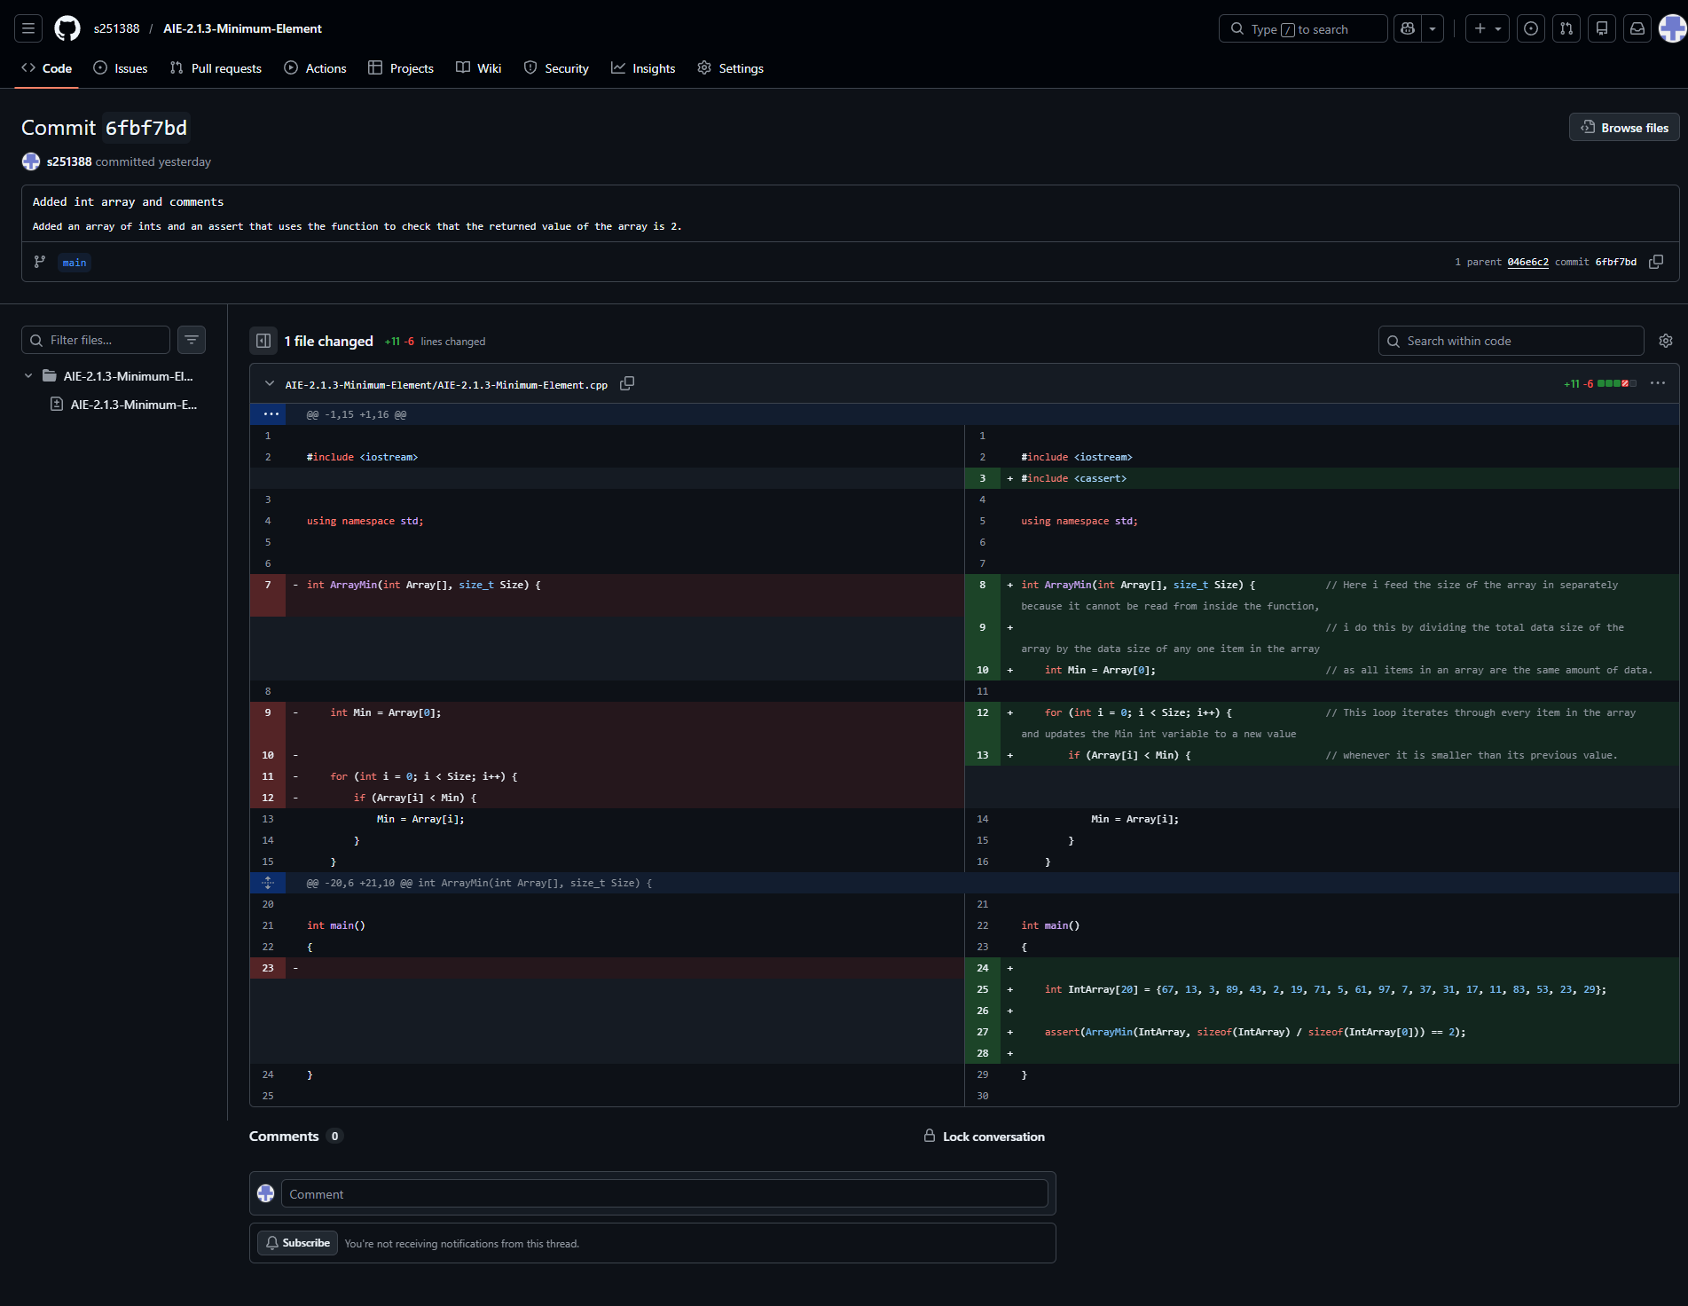

Resources:
- N/A, random knowledge from other projects
- Random information from site snippets in Google search

Challenges
Write a description of the challenges, mistakes made, or problems you personally encountered, and what you did to overcome, work around, or resolve these issues. (100 - 300 words).
Getting the function to understand the size of the array was a bit annoying, i was having all sorts of different problems experimenting with getting it to read it. Looking it up, the best solution according to alot of places was to use sizeof (gets the size of an array’s data) to divide the total size of the array by any given element of the array (as all elements in an array take up the same amount of data) to pass that into the function separately.

Weaknesses
Write a list of personal weaknesses regarding version control and ways you could resolve these weaknesses. (100 - 300 words).
I’m still having trouble fleshing out my own consistent “style” with writing code.
It’s feeling awkward sending separate commits for the function, and the testing of the function, i feel like normally these would always be committed together, i assume this is only being done for these assessment projects for educational purposes.

